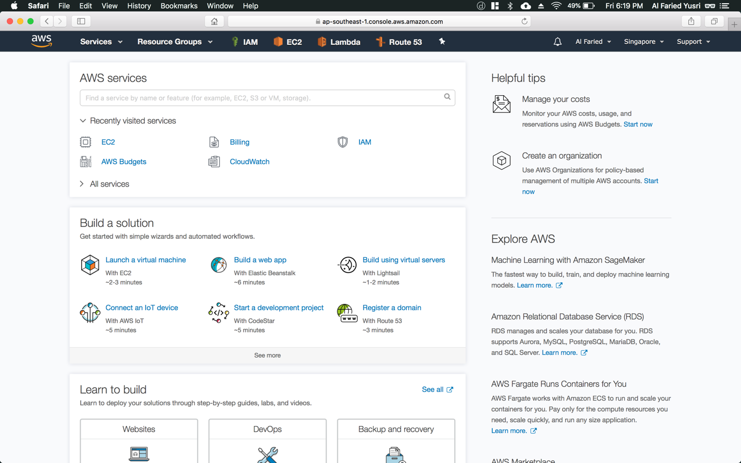

Step 1: Click on “Services” (refer to Figure 1.1) on the top left hand corner

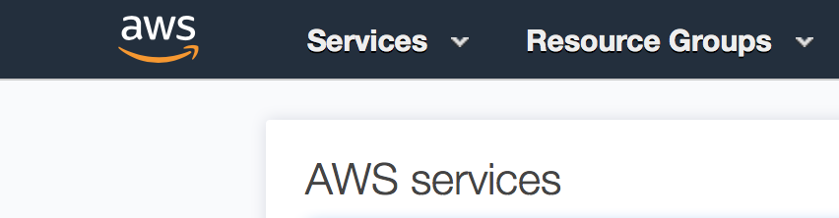

Figure 1.1

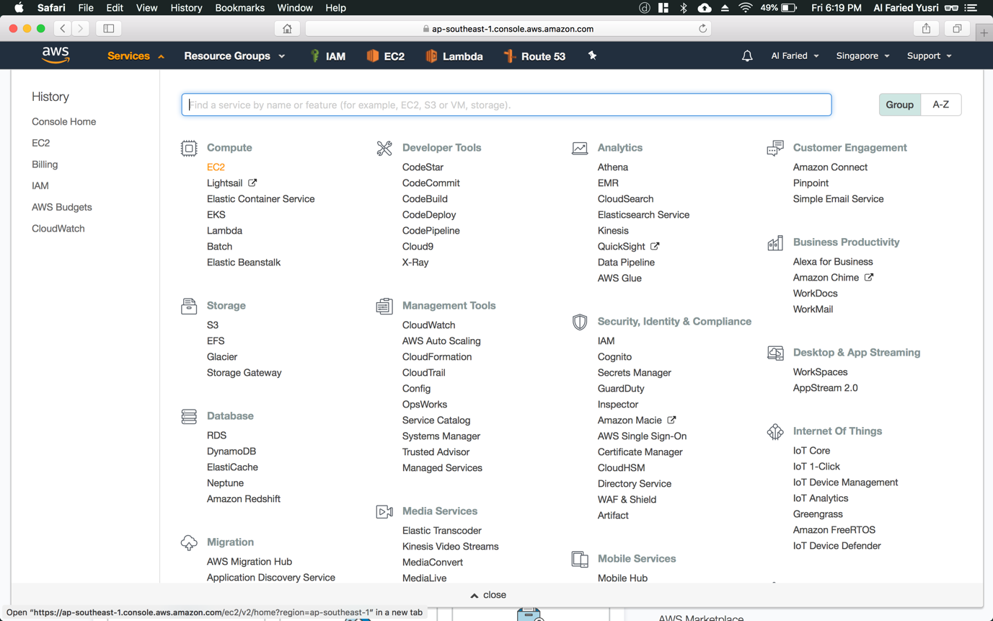

Step 2: Click “EC2” – The one that is highlighted in orange

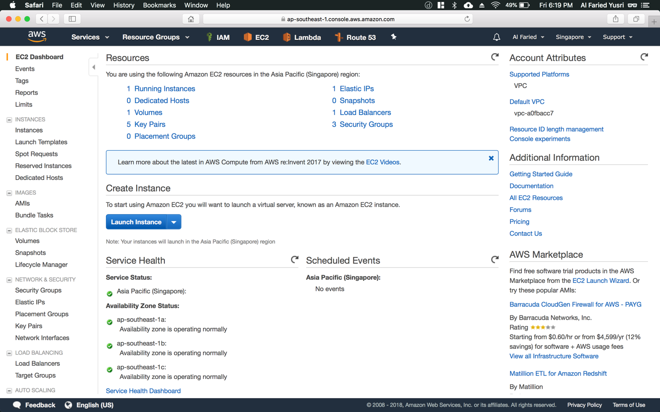

Step 3: Once you’re greeted with this page, click on “Launch Instance” button (refer to Figure 1.2)

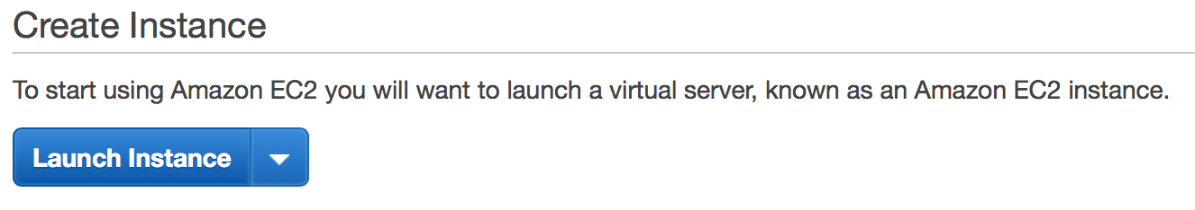

Figure 1.2

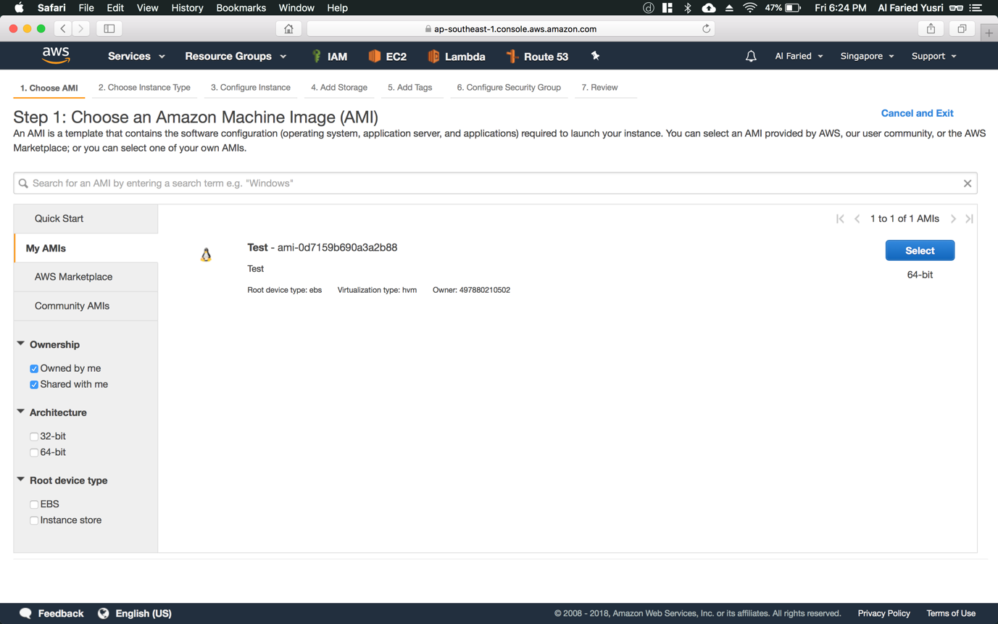

Step 4: Click on “My AMIs” and tick the “Shared with me” check box. You will then be able to see the AMIs that are share with you by the instructors

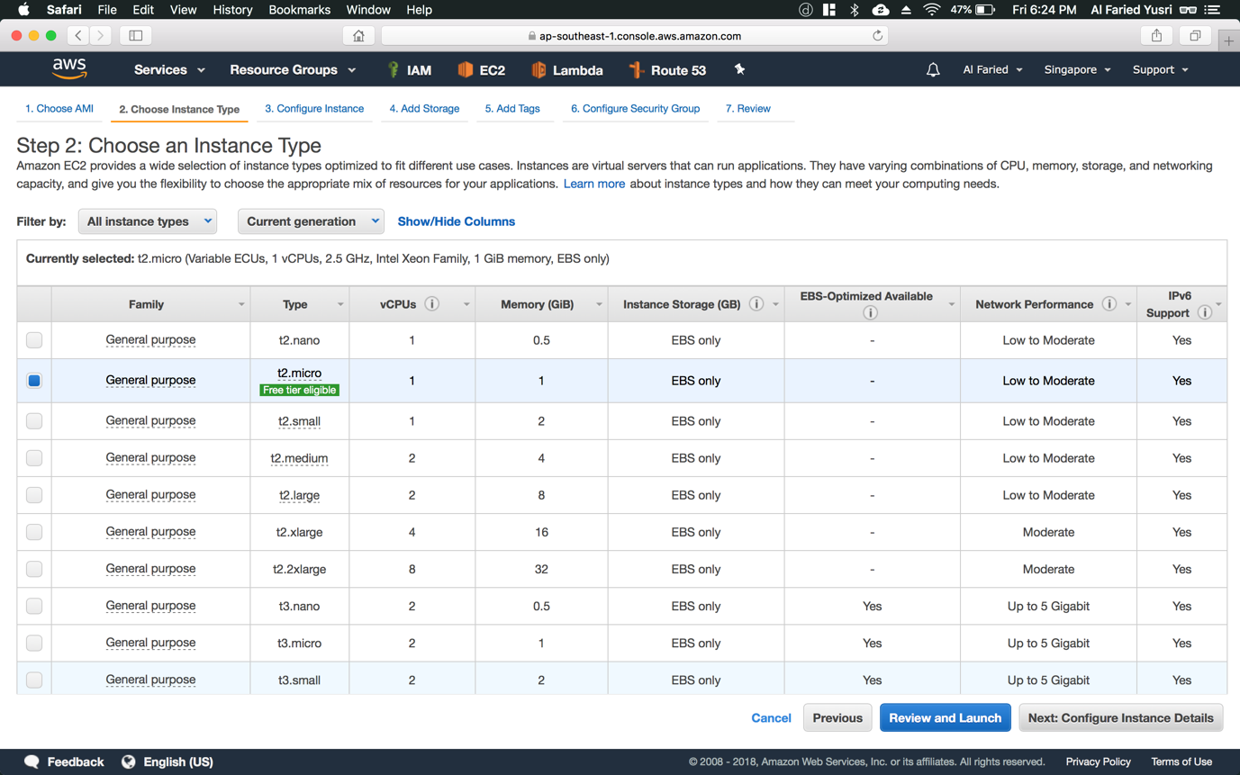

Step 5: Choose t2.micro and click on “Next: Configure Instance Details” button on the bottom right hand corner

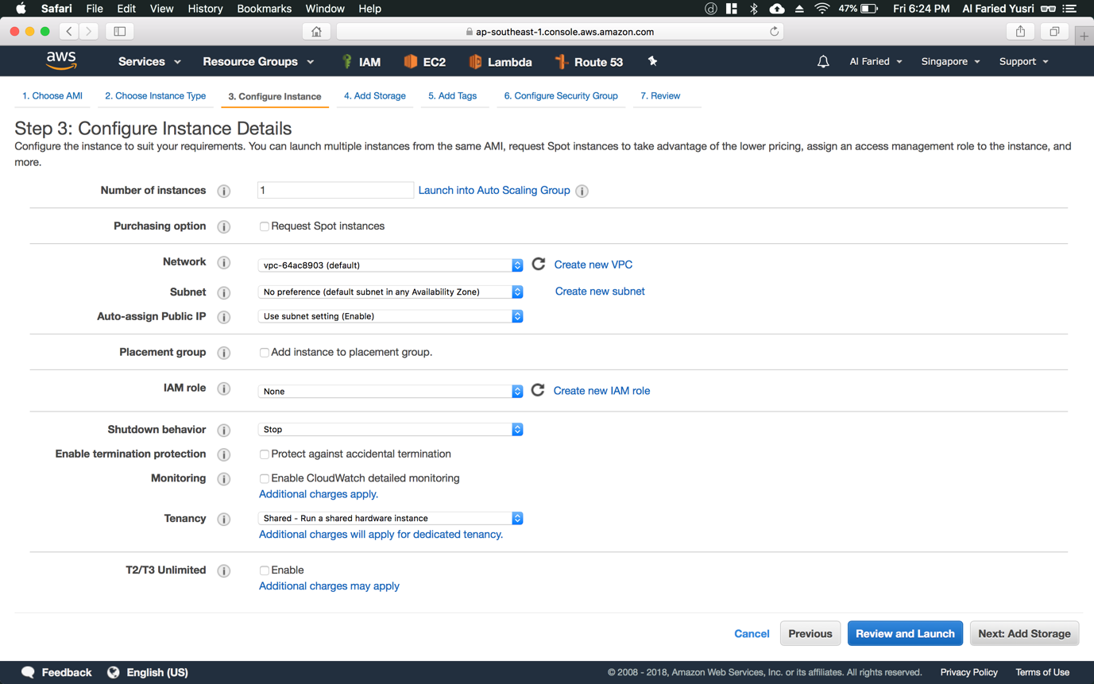

Step 6: Leave the settings to default and click on “Next: Add Storage” button

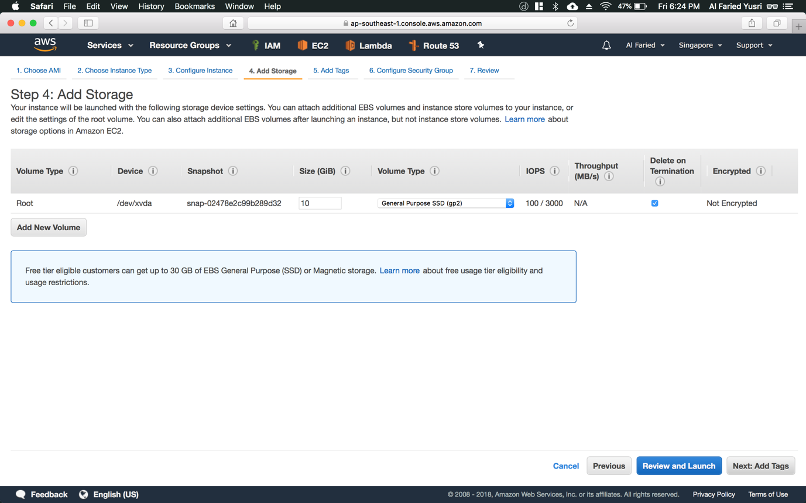

Step 7: Configure the volume size to be 10 GB and click on “Next: Add Tags” button

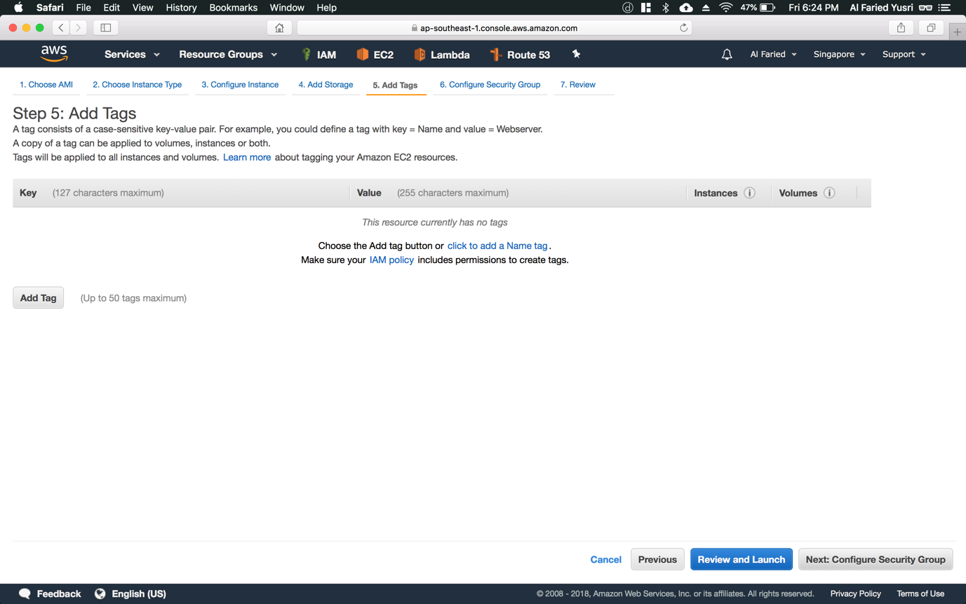

Step 8: This part is optional but if you which to add a name for your instance, just click on “Add Tag” button with the key being “Name” and the value being name that you want to give your instance. Else, if you choose not to configure any tags, just click on “Next: Configure Security Group” button

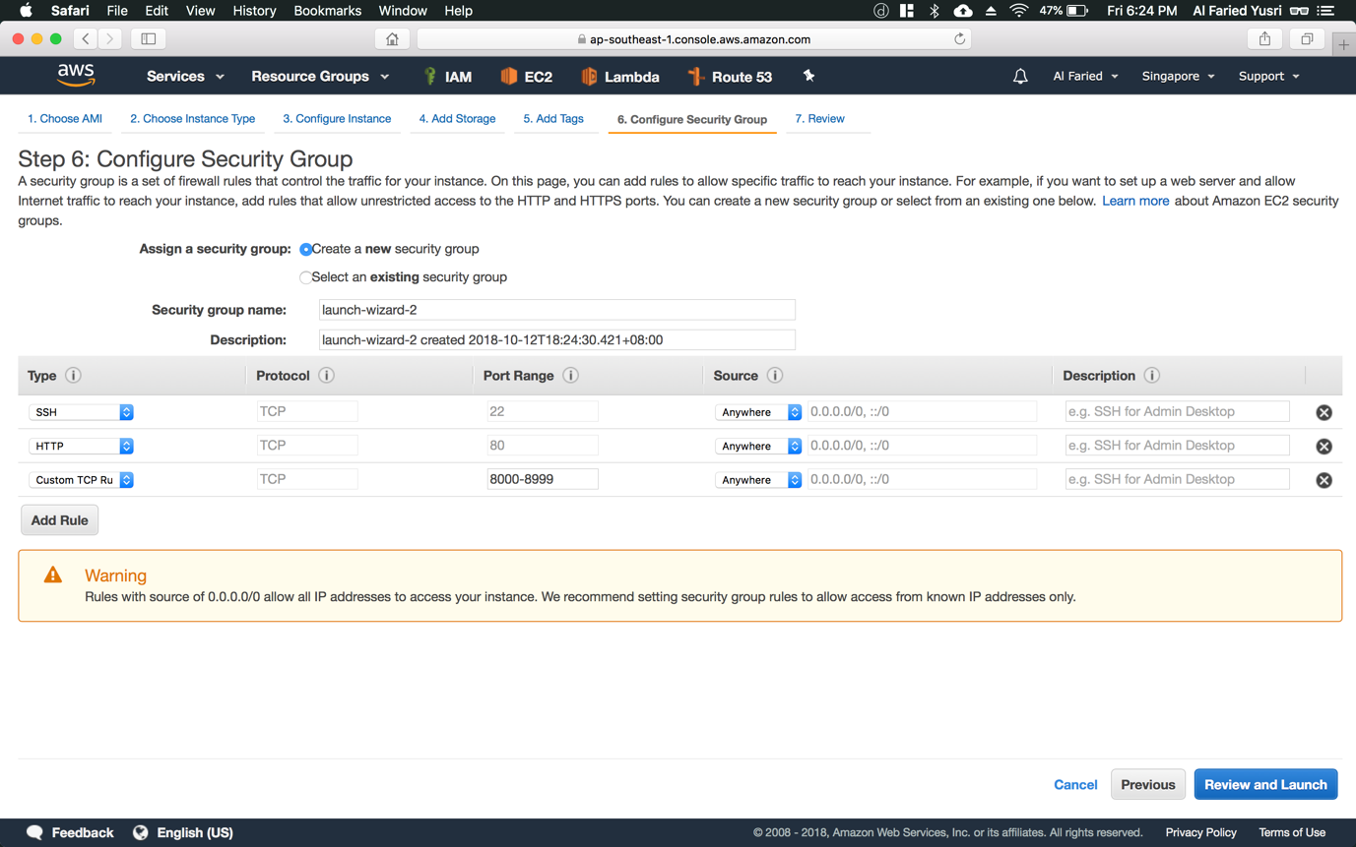

Step 9: Click on “Create a **new** security group” and input the following values according to the screenshots, and click on “Review and Launch” button

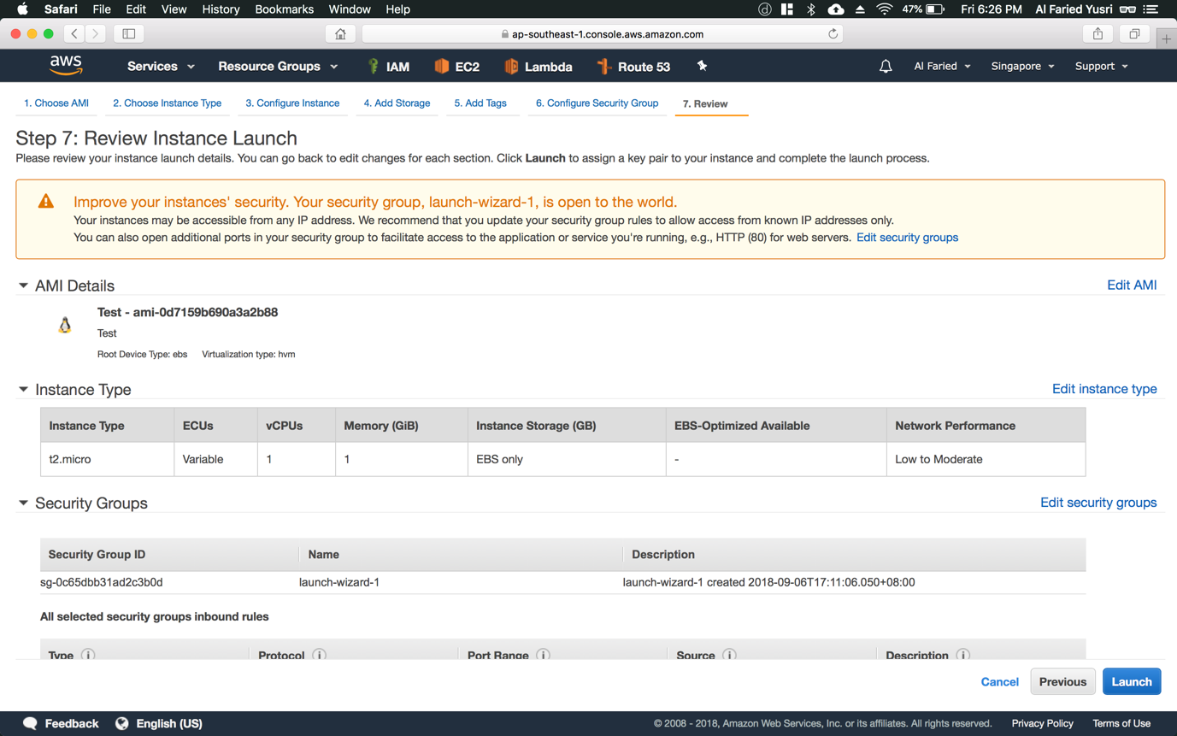

Step 10: Review your instance details. Once finalized, click on “Launch” button

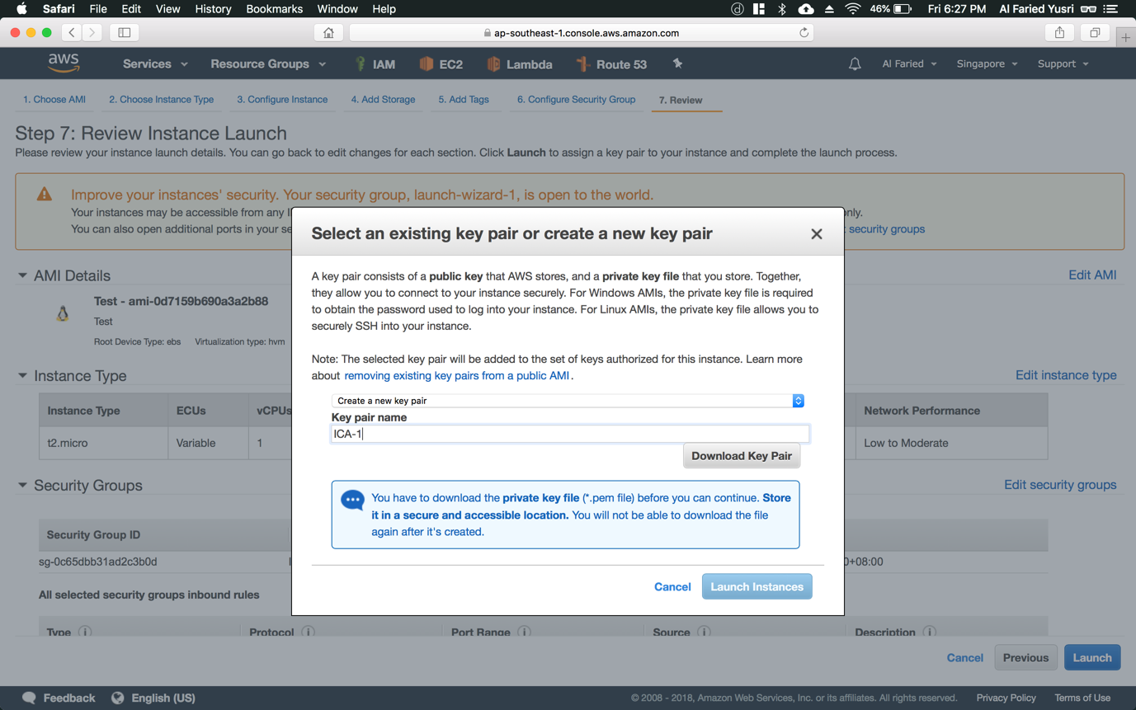

Step 11: Before launching your instance, click on “Create a new key pair” from the first dropdown list and type in your desired “Key pair name”. Once done, click on “Download Key Pair” button before clicking on “Launch Instances” button.

*\*Do take note, you would need this key pair to ssh into your launch instance*